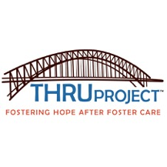
THRU Project Advisor Application

Each year, approximately 1,500 foster youth in Texas leave the state’s care, many without a permanent home or positive role model to provide them with support in their first years of adulthood. They have likely been in foster care most of their lives and will leave it without the ability to live independently. More important, they leave without an adult to help guide them during the most critical time in their lives.

There are resources available to former foster youth that will pay for higher education and job training, provide resources to low-income housing, assist with employment opportunities and emergency needs, but too few former foster youth access these resources. Volunteer Advisors agree to meet with their youth in person at least once per month and to augment those visits with a minimum of two phone calls, texts or emails per month. Advisors will focus on becoming a trusted role model to the youth and assist them in accessing the programs and resources available to former foster youth.

The mission of THRU Project is to provide youth aging out of foster care at least one caring adult to be that connection between the youth and the services they so desperately need and to help them achieve a life of independence. Becoming a THRU Project Advisor means telling a former foster youth they are not alone anymore.

THANK YOU for opening your heart today! THRU Project
Advisor Volunteer Application
8103 Broadway, Suite 201 San Antonio, TX. 78209
Phone: (210) 852-0220
www.thruproject.org

Date:

Legal Name:

(All three REQUIRED) First Name M.I. Last Name

Other Name(s) Used:

Home Phone:
Mobile phone:

Email: _____________________________________________

Sex:
Ethnicity:
Date of Birth:
/ /

Address:

City: TX ZIP:

From (Month)
(Year)
to (Month)
(Year)

* If less than 3 years, your previous address: Please note if you have lived at your current residence less than 3 years you will be required to provide fingerprints. THRU Project will reimburse you for the expense.

,

CITY ST ZIP

From (Month)
(Year)
to (Month)
(Year)

SSN:
- -
Highest Level of Education:

Marital Status:
# of Children:

Occupation:
Employer:

Emergency contact: Name:
Phone:

What day(s) of the week and time(s) are best for you to meet with your Youth?

How did you hear about the THRU Project? (circle one)

Church/ Radio / News / TV / Internet / Personal Referral/ Work Referral
Please include names is applicable:____________________________________________

Please list any experience which may enhance/affect your ability to work with foster youth:

Attributes: Please circle items below you have experience with or enjoy doing.

Animals
Artistic
Bi-lingual Camping Cars/Motorcycles Computers Construction Cooking Corporate Counselor
Crafts
Criminal Justice Driven
Easy going Education
Engineering/Mechanics

Entrepreneurship Exercise Extrovert Finance
Firefighting/EMS Fishing
Good listener Government/Civil History
Introvert Journalism Medicine Military Movies Museums Musical

Outdoor Photography Private Industry Reading Religious Sciences Sewing Shopping
Sports Summer time Swimming Theatre Travel
Video Games Working-with-Youth
Writing Winter Time Zoo

Others Not Listed:

Please give us a short bio on yourself to help us better match you with a Youth:

Have you had any personal experience involving the Department of Family and Protective Services, Child Protective Services, Juvenile Court, Foster Care or another Agency (Please

enter agency name:
If yes, please describe where and in what capacity:

As a THRU Project volunteer, you will to meet and advocate for youth, 16 and over, who are transitioning from foster care in the San Antonio area. Do you have any concerns?

What do you feel are the strengths and challenges you bring to this program?

Would you be comfortable mentoring a gay, lesbian, transgender youth?
Yes No

Would you be comfortable mentoring a youth who may have a physical or intellectual disability? ___Yes ____No

I hereby certify that the above information is correct and accurate to the best of my knowledge, and I authorize inquiries concerning my suitability as a THRU Project volunteer. I understand that all the information will be held in strict confidence and used only for the purpose of determining my suitability as a volunteer. I understand that qualities of a successful THRU Project volunteer include interpersonal skills, compassion, punctuality, and reliability. I further understand that if concerns arise, THRU Project reserves the right to reject an applicant at any time, including during the training process or after certification.
THRU Project may disclose to other agencies and organizations, which utilize volunteers, the fact that I applied for and/or served with THRU Project as a volunteer. Furthermore, all information obtained by THRU Project will be deemed to be the sole property of the Agency, and shall not be available to me or anyone outside the Agency. I understand and agree that I am not obligated if called upon to perform services of a THRU Project volunteer and that THRU Project is not obligated to assign or actively seek to assign a youth to me.

As a THRU PROJECT volunteer I will be willing to: (Please write yes or no)
Commit to a minimum of one year to being a THRU Project advisor
Participate in THRU Project’s volunteer training program
Visit in person with youth to whom I am assigned at least once month
Reply timely to a monthly survey of my activities with my youth

The criteria used in the selection of volunteers are to ensure that applicants are able to
meet the responsibilities of a THRU Project volunteer. No applicant will be rejected due to race, color, religion, national origin, gender, age, sexual orientation or disability. THRU

Project is guided in practice and policy by our organizational values, which include “embracing change, challenge and diversity.”

Signature Date

Print Name

Out of Country Address Verification Form

If you have ever lived outside of the Continental U. S. at any point please provide the address below.

Street Address

____________________ ___________________

City State/ Province/Country ZIP/Postal Code

From:

To:
MM/YYYY MM/YYYY

Any additional information you feel is pertinent please provide in the space below.

Printed Name

Signature
Date

Due to the nature of THRU Project volunteer’s responsibilities and contacts, a criminal background check of all applicants will be conducted through Verified Volunteers. It may also be processed with the Texas Department of Family and Protective Services to check for any history with Child Protective Services. Criminal Background Check Policy Potential and existing members of the Board of Directors, staff, and volunteer advocates are required to cooperate with a complete criminal record investigation through the Texas
Department of Family and Protective Services and any agency or entity THRU Project may utilize to assist in the investigation. No person is considered qualified who has had prior convictions for child abuse or neglect, or related acts that would pose a risk to children or to the program’s credibility. Candidates for Board of Director, Staff, or Volunteer will be eliminated for consideration based on, but not limited to, the following guiding principles:

-Zero tolerance for all registered sex offenders, all convictions of crimes against children and all convictions of violent acts.
-Persons with pending charges for child abuse and neglect, sexual assault, and violent acts offenses will be considered only after resolution of such charges.
-Any other offense that could hurt the credibility of the THRU Project organization will be considered on a case by case basis.

Have you ever been arrested or convicted of a crime including DWI?
Yes No

If yes, please state the offense, location, date and disposition:

Do you have any criminal charges currently pending? If yes, please explain:
Yes No

Do you have friends/family who may come in contact with the youth you may be assigned,

ever been arrested/charged or convicted of any sexual misconduct?
Yes No
If yes, please list relationship and whether or not you still have contact them:

Policy Acknowledgement
I hereby acknowledge that I have been informed that THRU Project conducts background investigations to obtain information on criminal history and Child Protective Services involvement. I understand that any information obtained will be used to aid in determining my qualifications for services as a Volunteer for THRU Project.
Volunteers accepted will be asked to sign a criminal background check policy and release of information. I understand that by refusing to sign a release of information for or submitting to any of the background checks THRU Project will reject my volunteer application.

Please sign and date if you have read and understood the criminal background check policy.

Signature Date

__________________________________________________________________________
Printed Name

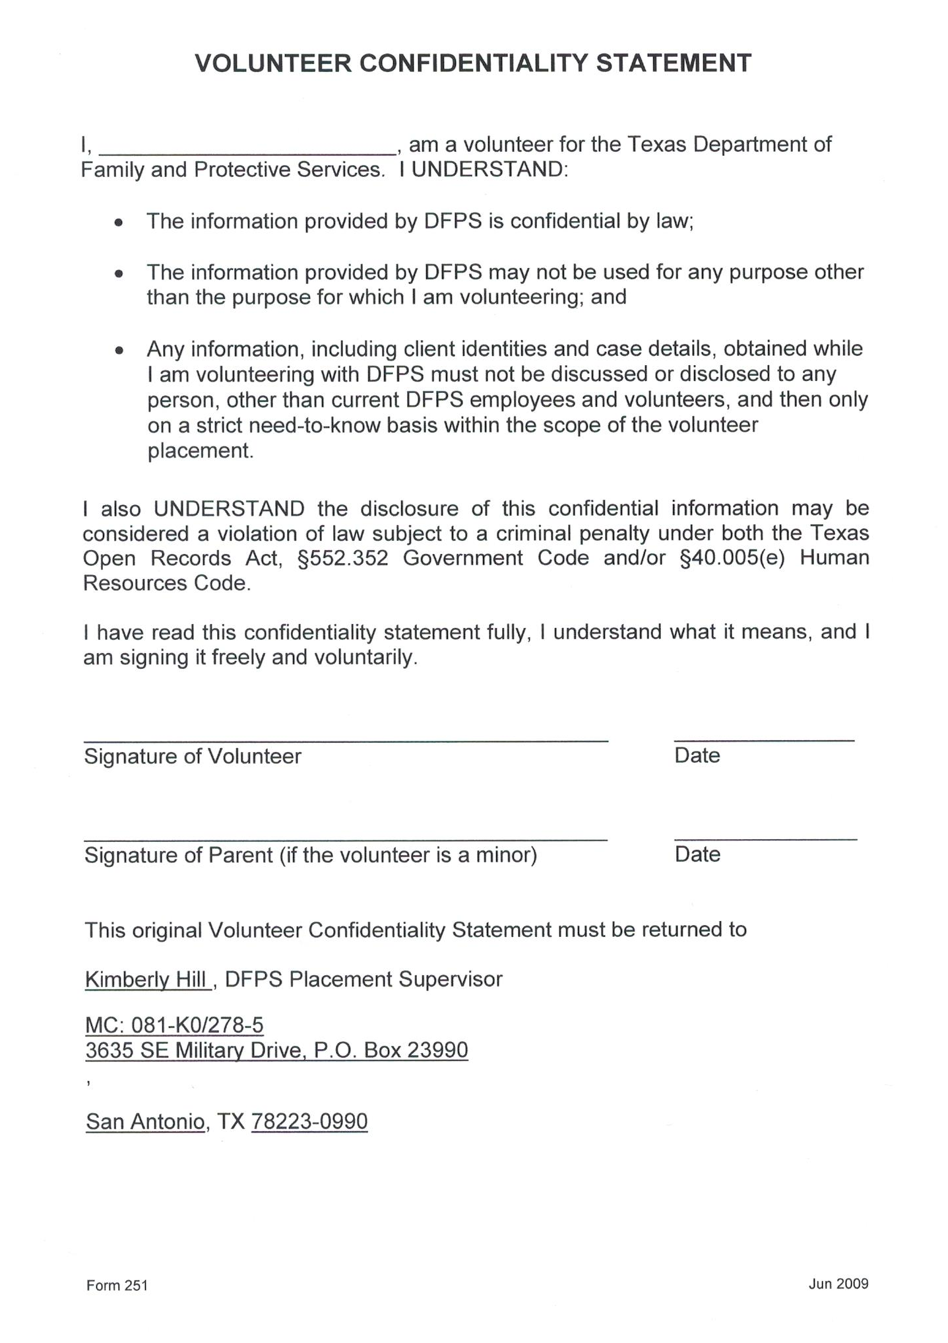

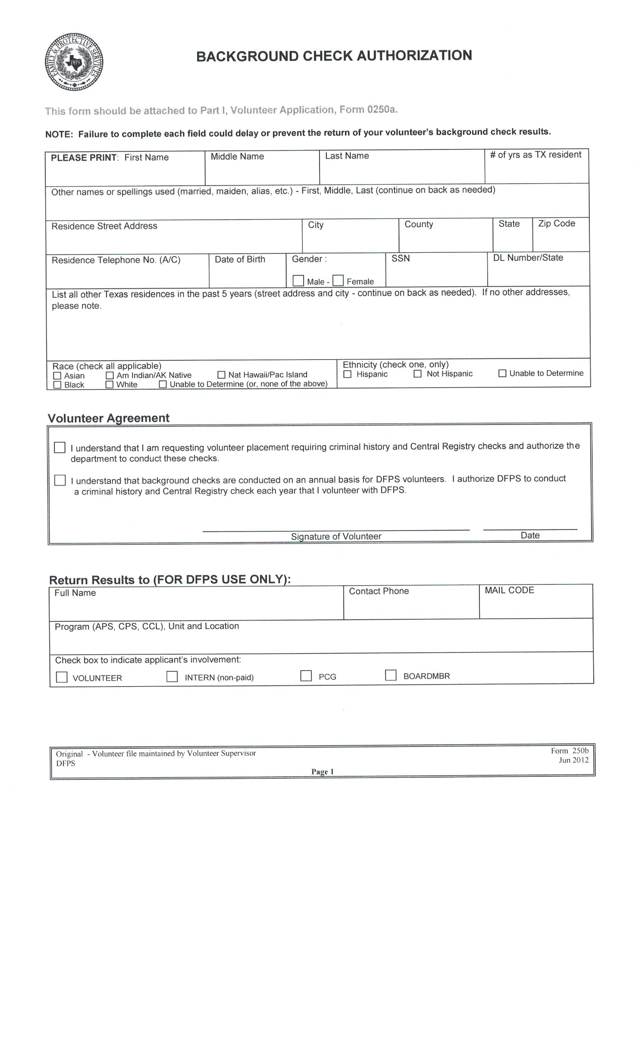

CONFIDENTIALITY ACKNOWLEDGEMENT

I shall respect the privacy of the people we serve. I shall hold in confidence all information obtained in the course of volunteer service whether that information is obtained through written records, information from other persons or interaction with the person.
I will not disclose an individual’s confidence to anyone except as mandated by law, to prevent a clear and immediate danger to a person or persons, or if compelled to do so by a court or pursuant to the rules of a court. I shall store or dispose of professional records in ways that maintain confidentiality. Upon my termination, I shall maintain client/staff confidentiality.

Volunteer Signature Date

AUTHORIZATION/CONSENT
During the application process and at any time during the tenure of my service with THRU Project, I hereby authorize THRU Project to utilize any agency or entity they desire to assist in the investigation to information regarding my character, general reputation, or personal characteristics. This report may be compiled with information from courts record repositories, departments of motor vehicles, past or present employers and educational institutions, governmental occupational licensing or registration entities, business or personal references, and any other source required to verify information that I have voluntarily supplied. I understand that I may request a complete and accurate disclosure of the nature and scope of the background verification, to the extent such investigation includes information bearing on my character, general reputation, or personal characteristics. These records may be requested on an annual basis.

Volunteer Applicant Signature Date

Printed Name

Please submit the application along with two (2) forms of ID (one must be a photo ID) to:

THRU Project
8103 Broadway, Suite 201 San Antonio, TX 78209
You may also leave your application at the Unity office in Suite 210 of the above address. Please Note it may take up to 2-3 weeks to complete the background check.
You will be informed by email as soon as it is complete.

THANK YOU FOR MAKING A DIFFERENCE TODAY!

